**Ideation Phase**

**Define the Problem Statements**

| Date | 19 September 2022 |
| --- | --- |
| Team ID | PNT2022TMID29438 |
| Project Name | AI power nutrition analyzer for fitness enthusiasts |
| Maximum Marks | 2 Marks |

**Customer Problem Statement Template:**

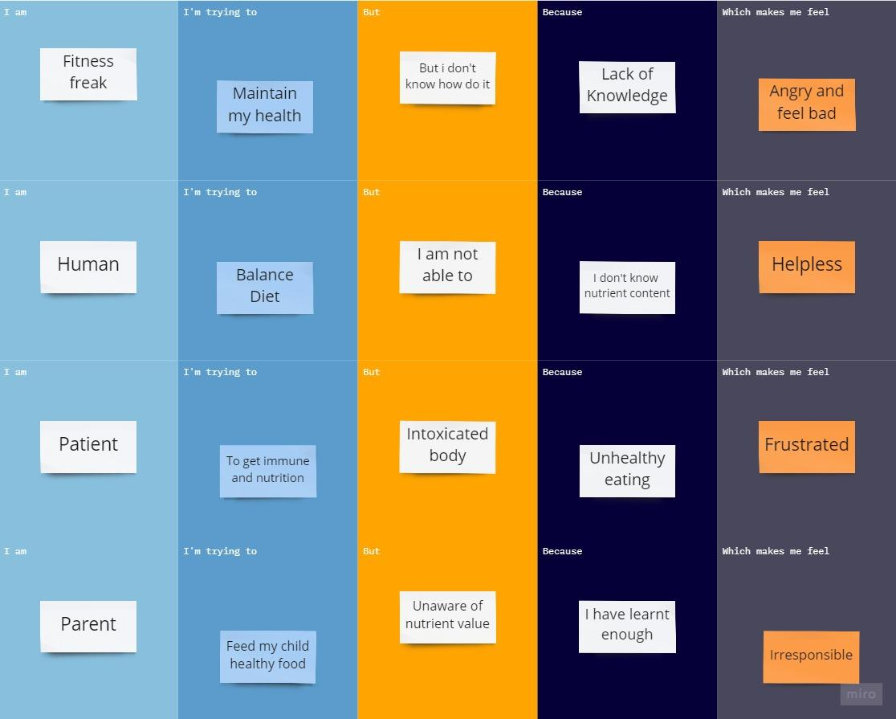

| **Problem Statement (PS)** | **I am (Customer)** | **I’m trying to** | **But** | **Because** | **Which makes me feel** |
| --- | --- | --- | --- | --- | --- |
| PS-1 | Fitness freak | Maintain my health | But i don't know how do it | Lack of Knowledge | Angry and feel bad |
| PS-2 | Human | Balance Diet | I am not able to it | I don't know nutrient content | Helpless |
| PS-3 | Patient | To get immune and nutrition | Intoxicated body | Unhealthy eating | Frustrated |
| PS-4 | Parent | Feed my child healthy food | Unaware of nutrient value | I have learnt enough | Irresponsible |